**James Chad Ballay**

Week 5 - CIS 313 – Cryptography – Random Number Lab

**Analyze Randomness**

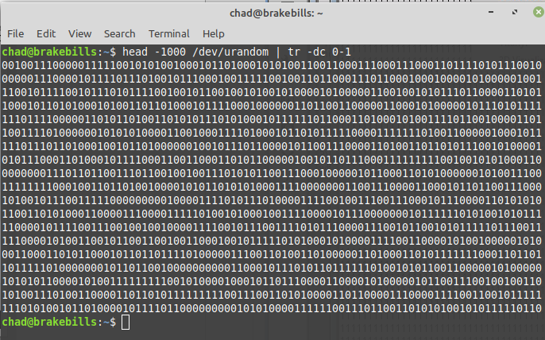

For my random input I decided to pipe in a selection of 0’s and 1’s from OSX’s built in random number generator device. (Urandom Man Page, 2019) This was done to ensure no bias of my own entered into the process. For my randomness analysis, I selected the Frequency Test option.